**Why Reading 20 Minutes At Home Leads To Becoming A Better Reader**

* **Student A** reads 20 minutes a day, which is 3,600 minutes per school year or 1,800,000 words per year. Scores in the 90th percentile on standardized tests.
* **Student B** reads minutes per day, or 900 minutes per school year or 282,000 words per year. Scores in the 50th percentile on standardized tests.
* **Student C** reads 1 minute per day, 180 minutes per school year or 8,000 words per year. Scores in the 10th percentile on standardized tests.

If a student reads as noted above starting in Kindergarten, by the end of 6th grade, Student A read for the equivalent of 60 school days, Student B for 12 school days, and Student C for 3 school days.

[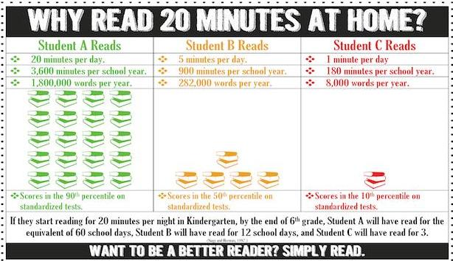](https://www.tn.gov/firstlady/read20/)