**Guatemala Facts**

* **Name:** Guatemala (long form) Republic of Guatemala
* **Capital City:** Guatemala City (1,104,890 pop.) (3,681,309 metro pop.)
* **Guatemala Population:**14,373,472 (*2013 est.*)
* [**Currency:**](https://www.worldatlas.com/aatlas/infopage/currconv.htm) Quetzal (GTQ), US dollar (USD), others accepted in major cities [**(conversion rates)**](https://www.worldatlas.com/aatlas/infopage/currconv.htm)**[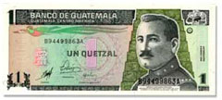](https://www.worldatlas.com/aatlas/infopage/currconv.htm)***One Guatemala Quetzal*
* **Ethnicity:** Mestizo (mixed Amerindian-Spanish - in local Spanish called Ladino) and European 59.4%, K'iche 9.1%, Kaqchikel 8.4%, Mam 7.9%, Q'eqchi 6.3%, other Mayan 8.6%, indigenous non-Mayan 0.2%, other 0.1%
* **GDP total:**$78.42 billion (*2012 est.*)
* **GDP per capita:** $5,200 (*2012 est.*)
* **Language:** Spanish (official), Amerindian
* **Largest Cities:** (*by population*) Guatemala City, Mixco, Villa Nueva, Petapa, San Juan Sacatepequez
* **Name:** The origin of the name Guatemala is Indian, but its meaning is undetermined. It is believed that the name Guatemala means "land of the trees" in the Maya-Toltec language.
* **Independence Day:** September 15
* **Religion:** Catholic, Protestant, Mayan beliefs

**Guatemala Coat of Arms:**

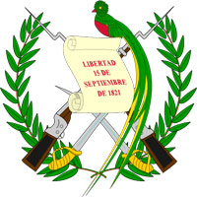

**Traditional Dishes From Guatemala-Yum,Yum!**

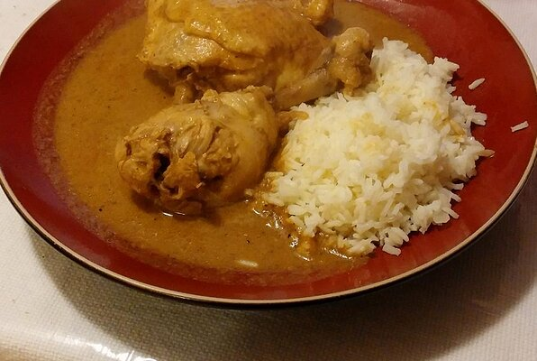**Recado de Pepian Indio**

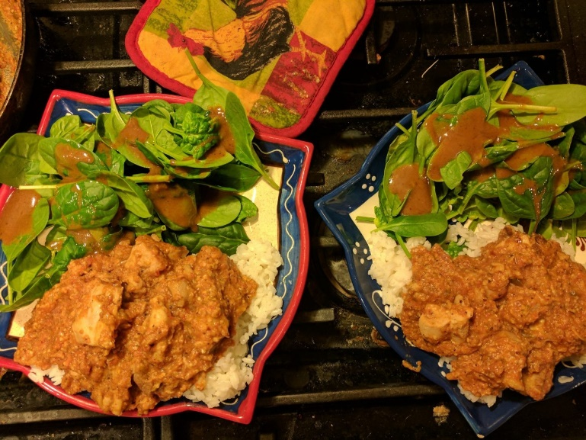Pepián de Pollo

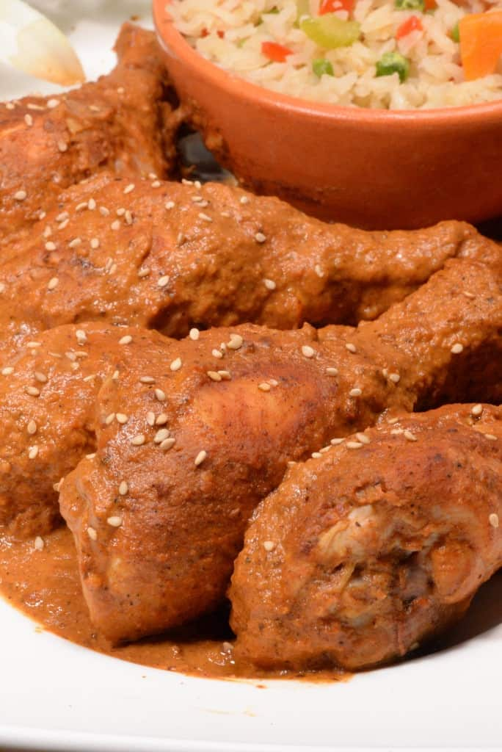 Pepián de Pollo